**Annual Activity Report 2016**

**Women with Disabilities Development Foundation (WDDF)**

**House#712/1, Road#10, Adabar, Bytul Aman housing Society,**

**Mohammadpur, Dhaka-1207**

**1st January to 31st December 2016**

1. **National Executive Council Meeting:**

**Six National Executive Council (NEC) meetings were held during this reporting year (From 01 January to 31 December 2016).**

**A)** The First **Executive Council (**EC) meeting was held on 7th January 2016. There were almost Ten participants including office staffs. Five agenda have been discussed including miscellaneous in this meeting.

**B)** The Second **Executive Council (**EC) meeting was held on 27th January 2016. There were almost Ten participants including office staffs. Three agenda have been discussed including miscellaneous in this meeting.

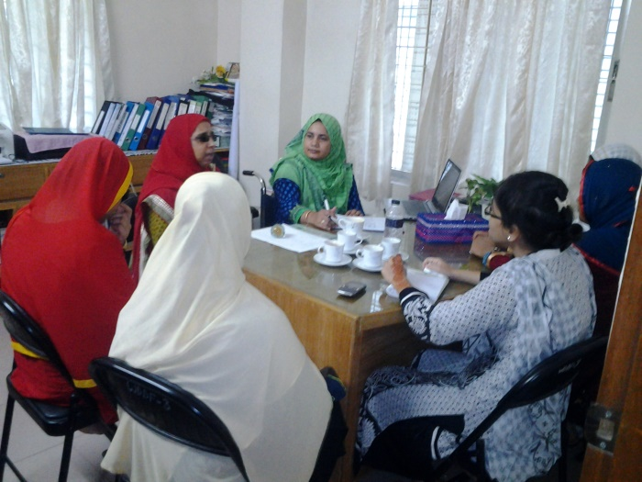**C)** The Third **Executive Council (**EC) meeting was held on 29th February 2015. There were almost Ten participants including office staffs. Four agenda have been discussed including miscellaneous in this meeting.

**D)** The Forth **Executive Council (**EC) meeting was held on 24th April 2016. There were almost Ten participants including office staffs. Five agenda have been discussed including miscellaneous in this meeting.

**E)** The Fifth **Executive Council (**EC) meeting was held on 1st August 2016. There were almost Ten participants including office staffs. Five agenda have been discussed including miscellaneous in this meeting.

F) The Sixth **Executive Council (**EC) meeting was held on 17th December 2016. There were almost Ten participants including office staffs. Five agenda have been discussed including miscellaneous in this meeting.

**2. Education Scholarship and support for Income Generating Activities (IGA) distribution programs:**

**One** Education Scholarship and One support for Income Generating Activities (IGA) distribution programs were being organized with the initiative of WDDF **in January 2016,**

Are as follows:

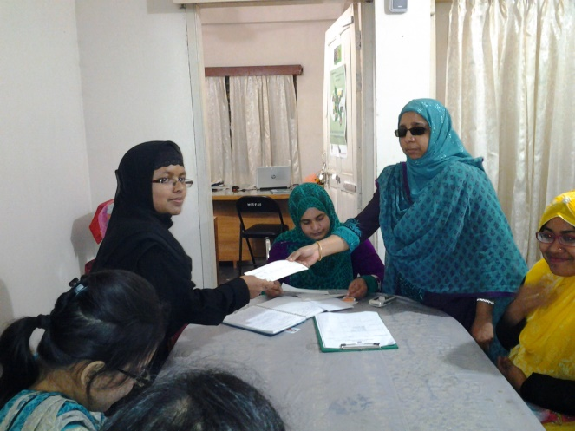A) One education scholarship distribution program with the initiative of WDDF, was being organized on 12th January 2016 at Manikganj Disable People’s Organization to Development (MDPOD). WDDF has distributed education scholarship among Four Girls’ With Disabilities.

B) One support for Income Generating Activities (IGA) distribution program with the initiative of WDDF, was being organized on 12th January 2016 at Manikganj Disable People’s Organization to Development (MDPOD). WDDF formed a group consist of 7 members of Grassroots WWDs committee under the supervision of MDPOD. This group is going to be established a small entrepreneurship at Manikganj. MDPOD Director Md.Entaj Ali was present there. WDDF & MDPOD signed a MOU. MDPOD will provide all cooperation for this group to run their entrepreneurship. WDDF is working hard to support for building discrimination free lives of WWDs with equal dignity.

**3. Exposure visit:**

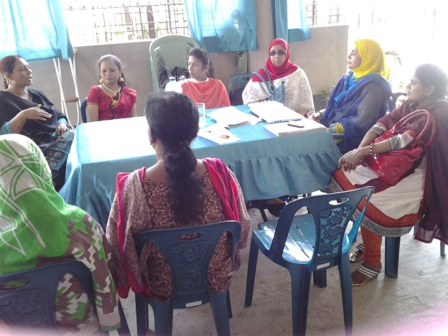An exposure visit was being organized with the initiative of WDDF, on 14th April2016, in Kustiya, Nikunja **Nari Unnayan Sangstha**. A number of issues e.g. types of current programs, the inclusion of WWDs with the activities and future work plan have been observed and discussed between the representatives of WDDF and Nikunja **Nari Unnayan Sangstha** in this visit. WDDF Chairperson, Shirin Akhter and Executive Director, Ashrafun Nahar Misti were discussed with the Executive Council Members of Nikunja **Nari Unnayan Sangstha**. Executive Director, Ashrafun Nahar Misti present the activities of WDDF. Accounts Coordinator Md. Hasanuzzaman and Project Officer Erona Khandakar were also being present there. Ferdowsi Rubi, Chairman, Nikunja **Nari Unnayan Sangstha** presided over the meeting along with discussed their different activities in brief and other Executive Council Members shared their experience about their challenges as WWDs with the representative team of WDDF.

**4. Discussion Meeting with Government and Non-Government Organizations:**

The main purpose of organizing these meetings is to ensure the inclusion of Women With Disabilities (WWDs) in all newly adopted policies and plan, which had not been happened before as well as for the implementation of Government along with international rules and regulations including “UN CONVENTION ON THE RIGHTS OF PERSONS WITH DISABILITIES”.

**Twenty seventh** Discussion Meetings were organized in various purposes in this reporting year (From 01 January to 31 December 2016).

1. **The 1st discussion meeting with Impact Foundation :**

WDDF organized a discussion meeting with Mr. Monsur Ahmed Chowdhury, Member, Executive Board, Disability Council International, Former Member, UN Committee on the Rights of Persons with Disabilities & Board Member of Action Aid held on 9th January 16 at Impact Bangladesh Foundation, Shamoly , Dhaka. WDDF Executive Director, Ashrafun Nahar Misti discussed about the organization and the future plan of WDDF. Mr. Monsur Ahmed Chowdhury suggested WDDF to develop a proposal about the leadership of Women with Disabilities in different level which help WDDF to collect fund & also interested to extend his cooperation for WDDF sustainability. Chairperson and other staffs of WDDF were present in this meeting.

B) **The 2nd discussion meeting With the UNO of Comilla & Narayanganj:**

WDDF Chairperson Shirin Akhter & Project Officer Tahseen Showkat met with The UNO of Comilla at 18th Jan’16 & the UNO of Narayanganj at 20th Jan’16 for collecting testimonial as WDDF worked at Comilla & Narayanganj. WDDF developed both areas a committee consist of 15 members. WDDF worked with this committee for developing their leadership & self-confidence. Both the UNO of Comilla Muhammad Asaduzzaman & Narayanganj Chumki Akhter Chowdhury agreed to give WDDF testimonial as WDDF worked here positively.

**C) The 3rd Discussion Meeting with Duskin team of Japan:**

A discussion meeting with the Duskin Team of Japan was held on 12th February’16, at Platinum Grant hotel, Banani, Dhaka.

This Japanese team has been organizing a Ten month leadership training entitled “Duskin Leadership Training” in Japan for the Leaders With Disabilities of the Asia Pacific countries for many years. WDDF Executive Director Ashrafunnahar and Project officer Tahseen Showkat were participated in this discussion meeting. As a Duskin leader, Ashrafunnahar, Executive Director, WDDF shared the existing situation of Bangladeshi PWDs, her working strategies and working experience for the advancement of WWDs as well as pointed out the recommendations about the applicants of Duskin Leadership training.

**D) The 4th Discussion meeting with donor organization:**

A discussion meeting with Christophel Blinden Mission (CBM), on the representation in “Disability Inclusive Development” in the policy and programs of CBM was being held on 24th February’16, in Austrelian Hi Commission, Gulshan2, Dhaka.

WDDF Executive Director Ashrafunnahar and Project officer Tahseen Showkat were participated in this discussion meeting. Ashrafunnahar, Executive Director, WDDF, on behalf of Disabled Peoples Organizations (DPOs) and WWDs shared her rational explanation about the inevitability of inclusion of DPOs along with PWDs in Disability Inclusive Development with the representatives of donor organizations as well as pointed out the time required recommendations regarding this issue. Furthermore, She also noted with high priority about the requirement of special opportunity for WWDs considering their vulnerability and backward situation.

**E) The 5thDiscussion Meeting with the Director (Join Secretary) Enforcement of Bangladesh Road and Transport Authority (BRTA):**

A discussion meeting was held with a Deligation of WDDF as well as the Director Enforcement of Bangladesh Road and Transport Authority (BRTA) on 16th May 2016, at 12 PM, in his office. The representatives of EC along with GC including the officials of WDDF attended in the above mentioned meeting. Bijoy Bhushan Pal, Director, Enforcement of Bangladesh Road and Transport Authority (BRTA) expressed his heartiest thanks to the representatives of WDDF.

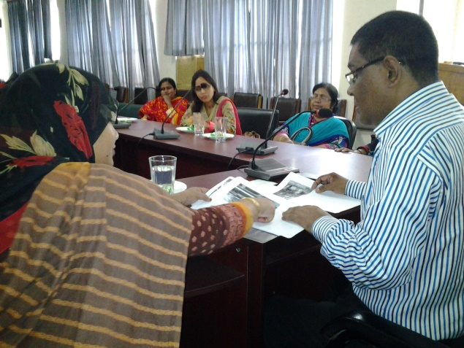Afterwards, Ashrafun Nahar, the Executive Director of WDDF, on behalf of the representatives of WDDF, submitted a paper including the accomplishmentn, objectives along with a few proposals and Shirin Akhter, Chairperson of WDDF, submitted a brief report on the activities for the promotion and protection of the rights along with dignity of WWDs to the Director and call upon to express the solidarity on behalf of BRTA to these issues.

The Director was very cordial and cooperative to us. He expressed His full support and solidarity to our proposals. He also said that, present Government is very compassionate to the PWDs and very much committed to fulfill their demands.

Above all, it is said that, in the present perspective, the adopted initiative by WDDF, of organizing this dialogue between the representatives of WDDF and the authority of BRTA in order to include the WWDs in the mainstream of development by ensuring their equal rights along with dignity is really very time required and effective. At the end of the discussion meeting, the representatives after having been attended in the above mentioned meeting expressed their satisfactory feelings and positive remarks.

**F) The 6th Discussion meeting with UNO of Narayanganj:**

A discussion meeting with the Upazila Nirbahi Officer (UNO) of Narayanganj was being held in her office, on 17th May 2016. The programs of NGOs, their working areas, repetition of same activities, organizing regular NGO coordination meeting, involvement of relevant Government officers with the activities of NGOs, the problems of the NGOs working in Narayanganj and solutions ETC are being discussed elaborately. Shirin Akhter, Chairperson and Erona Khandakar, Project Officer of WDDF were present in this meeting.

**G) The 7th Discussion Meeting with the Vice Chancellor (VC) of Islamic University of Technology (IUT):**

A discussion meeting was held with a Deligation of WDDF as well as the Vice Chancellor of Islamic University of Technology (IUT) on 18th May 2016, at 10 AM, in his office. The representatives of EC along with GC including the officials of WDDF attended in the above mentioned meeting.

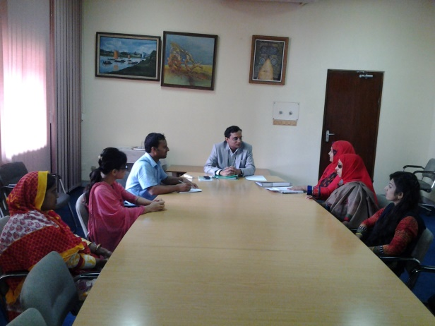Professor Dr. Munaz Ahmed Noor, Vice Chancellor, Islamic University of Technology (IUT) expressed his heartiest thanks to the representatives of WDDF. Afterwards, Ashrafun Nahar, the Executive Director of WDDF, on behalf of the representatives of WDDF, submitted a paper including the accomplishmentn, objectives along with a few proposals and Shirin Akhter, Chairperson of WDDF, submitted a brief report on the activities for the promotion and protection of the rights along with dignity of WWDs to the Vice Chancellor and call upon to express the solidarity on behalf of IUT to these issues.

The Vice Chancellor was very cordial and cooperative to us. He expressed His full support and solidarity to our proposals. He also said that, present Government is very compassionate to the PWDs and very much committed to fulfill their demands.

Above all, it is said that, in the present perspective, the adopted initiative by WDDF, of organizing this dialogue between the representatives of WDDF and the authority of IUT in order to include the WWDs in the mainstream of development by ensuring their equal rights along with dignity is really very time required and effective. At the end of the discussion meeting, the representatives after having been attended in the above mentioned meeting expressed their satisfactory feelings and positive remarks.

**H) The 8th Discussion Meeting with the Chairman of Bangladesh Road and Transport Corporation (BRTC):**

A discussion meeting was held with a Delegation of WDDF as well as the Chairman of Bangladesh Road and Transport Corporation (BRTC) on 25th May 2016, at 4 PM, in his office. The representatives of EC along with GC including the officials of WDDF attended in the above mentioned meeting.

Mohammad Mizanur Rahman Chairman of Bangladesh Road and Transport Corporation (BRTC) expressed his heartiest thanks to the representatives of WDDF. Afterwards, Ashrafun Nahar, the Executive Director of WDDF, on behalf of the representatives of WDDF, submitted a paper including the accomplishment, objectives along with a few proposals and Shirin Akhter, Chairperson of WDDF, submitted a brief report on the activities for the promotion and protection of the rights along with dignity of WWDs to the Chairman and call upon to express the solidarity on behalf of BRTC to these issues.

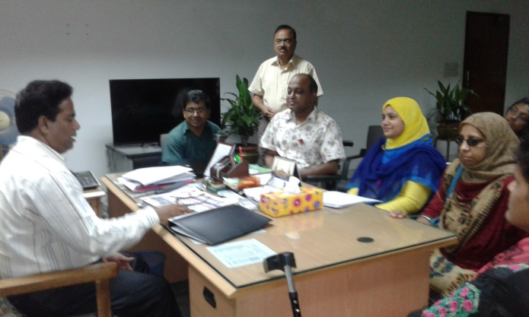The Chairman was very cordial and cooperative to us. He expressed His full support and solidarity to our proposals. He also said that, present Government is very compassionate to the PWDs and very much committed to fulfill their demands. Above all, it is said that, in the present perspective, the adopted initiative by WDDF, of organizing this dialogue between the representatives of WDDF and the authority of BRTC in order to include the WWDs in the mainstream of development by ensuring their equal rights along with dignity is really very time required and effective. At the end of the discussion meeting, the representatives after having been attended in the above mentioned meeting expressed their satisfactory feelings and positive remarks.

**I) The 9th Discussion Meeting with the Coordinator of Manusher Jonno Foundation (MJF):**

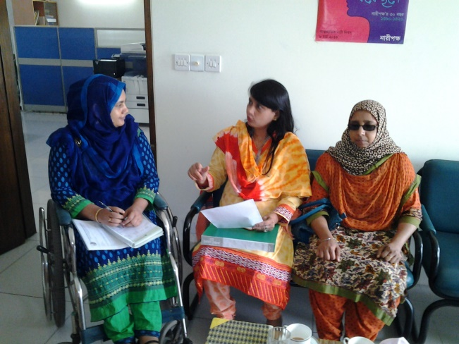A discussion meeting was held between the representatives of WDDF and the Coordinator of Manusher Jonno Foundation (MJF) on 5th June 2016, at 10 AM, in her office. The representatives of EC including the officials of WDDF attended in the above mentioned meeting. Nazrana Yesmin Hira, Coordinator, Manusher Jonno Foundation (MJF) expressed her heartiest thanks to the representatives of WDDF.

Afterwards, Ashrafun Nahar, the Executive Director of WDDF, on behalf of the representatives of WDDF, submitted a paper including the accomplishmentn, objectives along with a few proposals and Shirin Akhter, Chairperson of WDDF, submitted a brief report on the activities for the promotion and protection of the rights along with dignity of WWDs to the Coordinator and call upon to express the solidarity on behalf of MJF to these issues. The Coordinator was very cordial and cooperative to us. She expressed her full support and solidarity to our proposals. She also said that, present Government is very compassionate to the PWDs and very much committed to fulfill their demands.

Above all, it is said that, in the present perspective, the adopted initiative by WDDF, of organizing this dialogue between the representatives of WDDF and the authority of MJF in order to include the WWDs in the mainstream of development by ensuring their equal rights along with dignity is really very time required and effective. At the end of the discussion meeting, the representatives after having been attended in the above mentioned meeting expressed their satisfactory feelings and positive remarks.

**J) The 10th Discussion Meeting with the Executive Director of Nijera Kori:**

A discussion meeting on conducting a research about reproductive health of Women With Disabilities was being organized with the initiative of WDDF, on 9 June 2016, with Khushi Kabir, Executive Director,Nijera Kori in it’s office. The issues, E.G Researcher appointment, research method, to develop questionnaire to appoint volunteer for data collection and report preparation are being discussed elaborately. It is decided that, researcher will be appointed after Ramadan. Ashrafun Nahar, Executive Director, WDDF led this discussion meeting.

**K) The 11th Discussion Meeting with the Country Coordinator of Christoffel-Blinden Mission (CBM):**

A discussion meeting was held between the representatives of WDDF and the Country Coordinator including a number of representatives of Christoffel-Blinden Mission (CBM) on 22nd June 2016, at 10 AM, in CBM office. The representatives of EC including the officials of WDDF attended in the above mentioned meeting. Mohd. ShahNawaz Qureshi, Country Coordinator, Christoffel-Blinden Mission (CBM) expressed his heartiest thanks to the representatives of WDDF.

Afterwards, Ashrafun Nahar, the Executive Director of WDDF, on behalf of the representatives of WDDF, submitted a paper including the accomplishmentn, objectives along with a few proposals and Shirin Akhter, Chairperson of WDDF, submitted a brief report on the activities for the promotion and protection of the rights along with dignity of WWDs to the Country Coordinator and call upon to 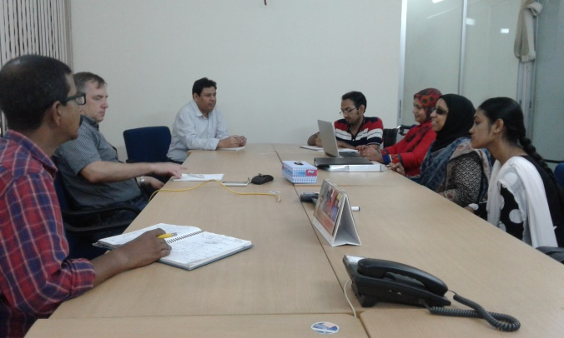express the solidarity on behalf of CBM to these issues.

The Country Coordinator was very cordial and cooperative to us. He expressed his full support and solidarity to our proposals. He also said that, present Government is very compassionate to the PWDs and very much committed to fulfill their demands.

Above all, it is said that, in the present perspective, the adopted initiative by WDDF, of organizing this dialogue between the representatives of WDDF and the authority of CBM in order to include the WWDs in the mainstream of development by ensuring their equal rights along with dignity is really very time required and effective. At the end of the discussion meeting, the representatives after having been attended in the above mentioned meeting expressed their satisfactory feelings and positive remarks.

**L) The 12th** **Discussion Meeting with the Chief Architect, Architecture Department:**

A discussion meeting was held between the representatives of WDDF and the Chief Architect of Architecture Department on 13th July 2016, at 11 AM, in his office. the officials of WDDF attended in the above mentioned meeting. Kazi Golam Nasir, Chief Architect, Architecture Department expressed his heartiest thanks to the representatives of WDDF.

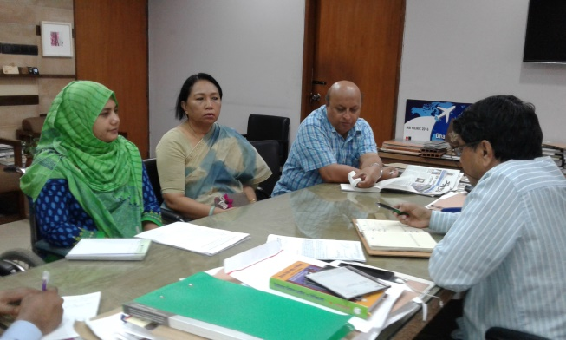Afterwards, Ashrafun Nahar, the Executive Director of WDDF, on behalf of the representatives of WDDF, submitted a proposal for organizing a seminar on ‘Accessibility of Persons with Disabilities including Women with Disabilities in Road, Footpath, Overbridge and Transport’, with the initiative of WDDF in collaboration with Architecture Department and call upon to express the solidarity on behalf of Architecture Department to this issue. The Chief Architect was very cordial and cooperative to us. He expressed his interest to organize a seminar regarding this issue and suggested to organize a discussion meeting with the President of Institute of Architecture Bangladesh (IAB), after organizing this meeting to consist a committee with the representatives from Three institutions (WDDF, Architecture department and IAB) for working together to organize this seminar. He expressed his full support and solidarity to our proposal. Hehe also said that, present Government is very compassionate to the PWDs and very much committed to fulfill their demands.

Above all, it is said that, in the present perspective, the adopted initiative by WDDF, of organizing this discussion meeting between the representatives of WDDF and the authority of Architecture Department in order to include the WWDs in the mainstream of development by ensuring their equal rights along with dignity is really very time required and effective. At the end of the discussion meeting, the representatives after having been attended in the above mentioned meeting expressed their satisfactory feelings and positive remarks.

**M) The 13th Discussion Meeting with the Chief News Editor, ATN News:**

A discussion meeting was held between the representatives of WDDF and the Chief News Editor of ATN News on 4th August 2016, at 4 PM, in ATN News Bhaban. The officials of WDDF attended in the above mentioned meeting. Ms. Munni Saha, Chief News Editor, ATN News expressed her heartiest thanks to the representatives of WDDF.

Afterwards, Ashrafun Nahar, the Executive Director of WDDF, on behalf of the representatives of WDDF, submitted a proposal for organizing a Talk Show on ‘Accessibility of Persons with Disabilities including Women with Disabilities in Road, Footpath, Overbridge and Transport’, with the initiative of WDDF and call upon to express the solidarity on behalf of ATN News to this issue. 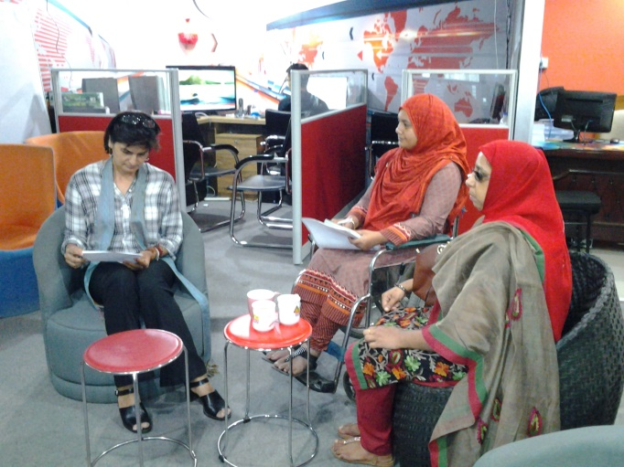

The Chief News Editor was very cordial and cooperative to us. She expressed her interest to organize a Talk Show regarding this issue and discussed about the detail budget and process to organize this type of Talk Show with WDDF. The representatives of WDDF were agreed to organize the Talk Show and Executive Director told that, After having been discussed officially about the budget and organizing process of Talk Show on ATN News, as soon as possible we’ll inform our decision about organizing this program.

Above all, it is said that, in the present perspective, the adopted initiative by WDDF, of organizing this discussion meeting between the representatives of WDDF and the Chief News Editor of ATN News in order to include the Women with Disabilities in the mainstream of development by ensuring their accessibility rights through media campaign is really very time required and effective. At the end of the discussion meeting, the representatives after having been attended in the above mentioned meeting expressed their satisfactory feelings and positive remarks.

**N) The 14th Discussion Meeting with the Chairman of National Human Rights Commission (NHRC):**

A discussion meeting was held between the representatives of WDDF and the Chairman of National Human Rights Commission (NHRC) on 16th August 2016, at 11 AM, in NHRC office. The representatives of EC including the officials of WDDF attended in the above mentioned meeting.

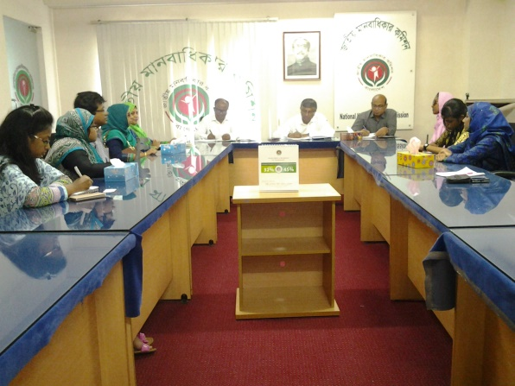Kazi Reazul Hoq, Chairman of National Human Rights Commission (NHRC) expressed his heartiest thanks to the representatives of WDDF. Afterwards, Ashrafun Nahar, the Executive Director of WDDF, on behalf of the representatives of WDDF, submitted a paper including the accomplishment, objectives along with a few proposals and Shirin Akhter, Chairperson of WDDF, submitted a brief report on the activities for the promotion and protection of the rights along with dignity of WWDs to the Chairman and call upon to express the solidarity on behalf of NHRC to these issues. Simultaneously, He adopted decision to send Two Demy Official letters on behalf of NHRC to the Chairman of Civil Aviation and Secretary of Road, Transport and Bridge Ministry in order to take necessary initiatives for ensuring the accessibility of Persons With Disabilities including Women with Disabilities as well as selected Two Women representatives with Disabilities(Chairperson and Executive Director) on behalf of WDDF to include in ‘Persons with Disabilities and Autism Committee’ of NHRC. He also said that, present Government is very compassionate to the PWDs and very much committed to fulfill their demands. Above all, it is said that, in the present perspective, the adopted initiative by WDDF, of organizing this dialogue between the representatives of WDDF and the authority of NHRC in order to include the WWDs in the mainstream of development by ensuring their equal rights along with dignity is really very time required and effective. At the end of the discussion meeting, the representatives after having been attended in the above mentioned meeting expressed their satisfactory feelings and positive remarks.

**O) The 15th Discussion meeting with the Mayor of North City Corporation (NCC):**

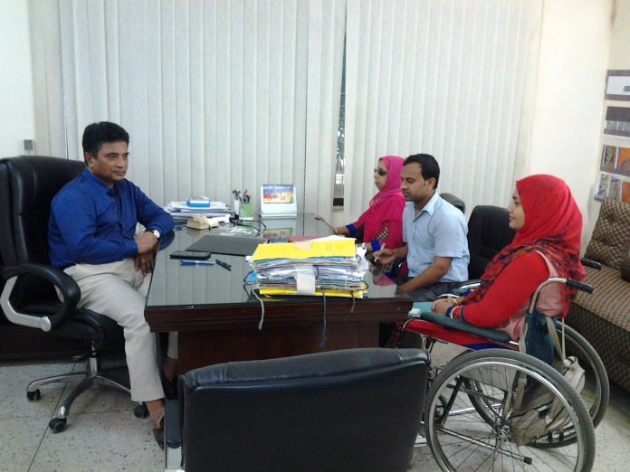A discussion meeting was held between the representatives of WDDF and the Mayor of North City Corporation (NCC) on 22nd August 2016, at 5.00 PM, in North City Corporation office. The representatives of EC including the officials of WDDF attended in the above mentioned meeting. Mr. Anisul Hoque, Mayor of North City Corporation (NCC) expressed his heartiest thanks to the representatives of WDDF. Afterwards, Ashrafun Nahar, the Executive Director of WDDF, on behalf of the representatives of WDDF, submitted a paper including the accomplishment, objectives along with a few proposals and Shirin Akhter, Chairperson of WDDF, submitted a brief report on the activities for the promotion and protection of the rights along with dignity of WWDs to the Mayor and call upon to express the solidarity on behalf of NCC to these issues. The representatives of WDDF also pointed out that, the newly constructed NCC Bhaban and footpaths are not accessible for Persons specially Women with Disabilities. Acknowledging this reality the Mayor told that, unintentionally this issue of accessibility was out of their consideration but it is immensely an important issue for building and designing an inclusive city for Persons specially Women with Disabilities and from this moment they will consider this issue in accordance with these proposals in the subsequent construction and designing of new buildings and footpaths. He also mention that, present Government is very compassionate to the Persons with Disabilities and very much committed to fulfill their demands. Above all, it is said that, in the present perspective, the adopted initiative by WDDF, of organizing this dialogue between the representatives of WDDF and the authority of NCC in order to include the Women with Disabilities in the mainstream of development by ensuring their equal rights along with dignity is really very time required and effective. At the end of the discussion meeting, the representatives after having been attended in the above mentioned meeting expressed their satisfactory feelings and positive remarks.

**P) The 16th Discussion meeting with the Chief Executive Officer of Mayor of South City Corporation (SCC):**

A discussion meeting was held between the representatives of WDDF and the Chief Executive Officer (CEO) of the Mayor of South City Corporation (SCC) on 23rd August 2016, at 12.00 PM, in South City Corporation office. The representatives of EC including the officials of WDDF attended in the above mentioned meeting. Khan Mohammad Bilal, Chief Executive Officer (CEO) of Mayor of South City Corporation (SCC) expressed his heartiest thanks to the representatives of WDDF. Afterwards, Shirin Akhter, Chairperson of WDDF, on behalf of the representatives of WDDF, submitted a paper 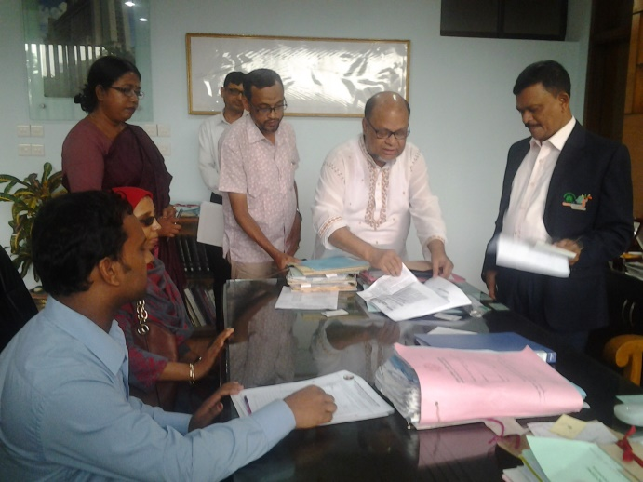including the accomplishment, objectives along with a few proposals and call upon to express the solidarity on behalf of SCC to these issues. The representatives of WDDF also pointed out that, the newly constructed footpaths are not accessible for Persons specially Women with Disabilities. The CEO also mention that, present Government is very compassionate to the Persons with Disabilities and very much committed to fulfill their demands. Above all, it is said that, in the present perspective, the adopted initiative by WDDF, of organizing this dialogue between the representatives of WDDF and the authority of SCC in order to include the Women with Disabilities in the mainstream of development by ensuring their equal rights along with dignity is really very time required and effective.

**Q) The 17th Discussion meeting with the Women and Human Rights activists:**

A discussion meeting with the Women and Human Rights activists was held amongst of the representatives of WDDF and the Women and Human Rights activists of different Women and Human rights based organizations including Disabled Peoples Organizations (DPOs) at 3.00 PM, on 24th August 2016, at the Auditorium of Steps Towards Development (STD). This discussion meeting is being organized by Women with Disabilities Development Foundation (WDDF).

At the starting of the discussion meeting, an introductory session of all the participants and representatives is being conducted by Ashrafun Nahar, Executive Director, WDDF and all the participants are introduced with each other in this session. After having introductory session been finished, welcome remarks is being delivered by Ranjon Karmakar, Executive Director, Steps Towards Development (STD).

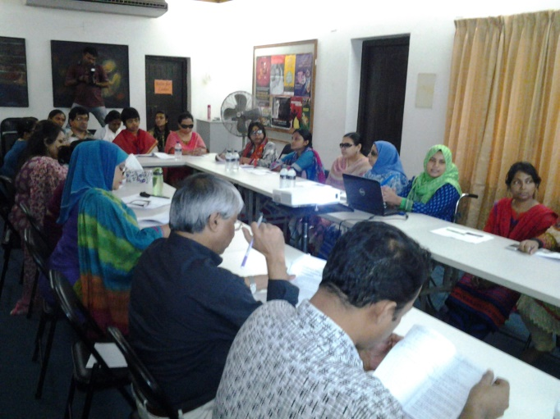The keynote paper is being presented by Ashrafun Nahar, Executive Director, WDDF. The overall situation of Women with Disabilities specially different types of discriminations Viz: Inequitable socio-economic status, depriving from the enjoyment of basic rights, negligence, violence, inaccessibility in infrastructural, informational areas even in justice, violation of human rights, including many significant areas of human life concurrently, the responsibilities of Women and human rights activists for the advancement of Women with Disabilities are being discussed in this keynote paper.

The participants of the open discussion have clearly been stated that, the issue of Women with Disabilities should be included in policy, planning and program level of women and human rights based organizations considering their special requirements. Otherwise their participation and inclusion in mainstream development will extremely be interrupted.

This discussion meeting is moderated by Ranjon Karmakar, Executive Director, Steps Towards Development (STD). Closing speech and vote of thanks is delivered by Farzana Mazid, Gender Specialist, Institute of Cholera and Diarrhoeal Diseases Research Bangladesh (ICDDRB).

**R) The 18th Discussion Meeting with the President, Institute of Architect Bangladesh (IAB):**

A discussion meeting was held between the representatives of WDDF and the President of Institute of Architect Bangladesh (IAB)on 24th August 2016, at 7 PM, in his office. the officials of WDDF attended in the above mentioned meeting.

Abu Sayeed M Ahmed, President, Institute of Architect Bangladesh (IAB) expressed his heartiest thanks to the representatives of WDDF.

Afterwards, Ashrafun Nahar, the Executive Director of WDDF, on behalf of the representatives of WDDF, submitted a proposal for organizing a seminar on ‘Accessibility of Persons with Disabilities including Women with Disabilities in Road, Footpath, Overbridge and Transport’, with the initiative of WDDF in collaboration with Architecture Department along with Institute of Architect Bangladesh (IAB)and call upon to express the solidarity on behalf of Institute of Architect Bangladesh (IAB) to this issue.

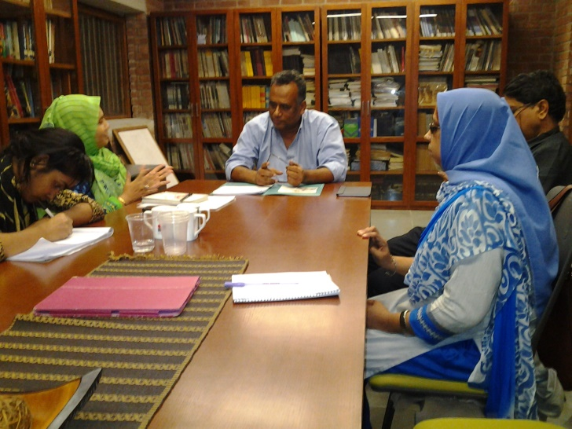The President was very cordial and cooperative to us. He expressed his interest to organize a seminar regarding this issue and decision is adopted that, a letter will be sent on behalf of WDDF to the President for nominating a representative in order to coordinate the tasks of organizing this seminar. He expressed his full support and solidarity to our proposal.

Above all, it is said that, in the present perspective, the adopted initiative by WDDF, of organizing this discussion meeting between the representatives of WDDF and the authority of Institute of Architect Bangladesh (IAB) in order to include the Women with Disabilities in the mainstream of development by ensuring their equal rights along with dignity is really very time required and effective. At the end of the discussion meeting, the representatives after having been attended in the above mentioned meeting expressed their satisfactory feelings and positive remarks.

**S) The 19th Discussion Meeting with the representatives of Christoffel-Blinden Mission (CBM):**

A discussion meeting was held between the representatives of WDDF and the representatives of Christoffel-Blinden Mission (CBM) on 5th September 2016, at 11 AM, in CBM office. Ashrafun Nahar, Executive Director and Reshma Akter, Project Officer of WDDF attended in the above mentioned meeting. Mr. Andrias,Coordinator, Disability Inclusive Development, Christoffel-Blinden Mission (CBM) expressed his heartiest thanks to the representatives of WDDF.

Afterwards, CBM representative expressed the interest of CBM to develop a network but Ashrafun Nahar enlightened that, there are already Three/four networks are working on disability issue and at present we think that there is no requirement of developing any network rather a consortium might be developed. So, Andrias agreed with the representative of WDDF and she submitted a proposal in order to develop a consortium of DPOs. She also discussed about the consortium of women led organizations. The draft proposal is attached below:

**T) 20th Discussion Meeting with the Director General, NGO Affairs Bureau:**

A discussion meeting was held between the representatives of WDDF and the Director General of NGO Affairs Bureau on 20th September 2016, at 11 AM, in NGO Affairs Bureau office. The representatives of EC including the officials of WDDF attended in the above mentioned meeting.

Md. Ashadul Islam, Director General of NGO Affairs Bureau expressed his heartiest thanks to the representatives of WDDF. Afterwards, Ashrafun Nahar, the Executive Director of WDDF, on behalf of the representatives of WDDF, submitted a paper including the accomplishment, objectives along with a few proposals and Shirin Akhter, Chairperson of WDDF, submitted a brief report on the activities for the promotion and protection of the rights along with dignity of WWDs to the Director General and call upon to express the solidarity on behalf of NGO Affairs Bureau to these issues. Simultaneously, He adopted decision to take required initiatives to solve the existing complexity and lengthy process of project approval along with the registration process of DPOs. He also said that, present Government is very compassionate to the Persons With Disabilities and very much committed to fulfill their demands.

Above all, it is said that, in the present perspective, the adopted initiative by WDDF, of organizing this dialogue between the representatives of WDDF and the authority of NGO Affairs Bureau in order to include the Women with Disabilities in the mainstream of development by ensuring their equal rights along with dignity is really very time required and effective. At the end of the discussion meeting, the representatives after having been attended in the above mentioned meeting expressed their satisfactory feelings and positive remarks.

**V) The 21stDiscussion Meeting with the Secretary of MOWCA:**

A discussion meeting was held between the representatives of WDDF and the Secretary of Ministry of Women and Children Affairs (MOWCA) on 9th October 2016, at 11 AM, in her office. The representatives of WDDF attended in the above mentioned meeting. Nasima Begum (NDC), 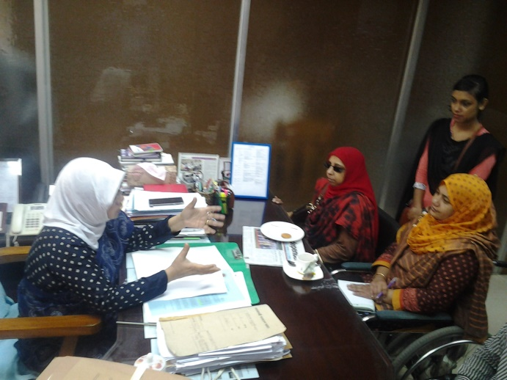Secretary of Ministry Women and Children Affairs (MOWCA) expressed her heartiest thanks to the representatives of WDDF. Afterwards, Ashrafun Nahar, the Executive Director of WDDF, on behalf of the representatives of WDDF, submitted a paper including the accomplishment, objectives along with a few proposals and Shirin Akhter, Chairperson of WDDF, submitted a brief report on the activities for the promotion and protection of the rights along with dignity of WWDs to the Secretary and call upon to express the solidarity on behalf of MOWCA to these issues. Simultaneously, She adopted decision to communicate with the Secretary of Road, Transport and Bridge Ministry in order to organize a meeting with the representatives of WDDF and take necessary initiatives for ensuring the accessibility of Persons With Disabilities including Women with Disabilities. She also said that, present Government is very compassionate to the Persons with disabilities and very much committed to fulfill their demands. Above all, it is said that, in the present perspective, the adopted initiative by WDDF, of organizing this dialogue between the representatives of WDDF and the Secretary of MOWCA in order to include the Women with Disabilities in the mainstream of development by ensuring their equal rights along with dignity is really very time required and effective. At the end of the discussion meeting, the representatives after having been attended in the above mentioned meeting expressed their satisfactory feelings and positive remarks.

**V) The 22nd Discussion meeting with the Secretary of Road, Transport and Bridge Ministry:**

A discussion meeting was held between the representatives of WDDF and the Secretary of Road, Transport and Bridge Ministry on 17th October 2016, at 11.00 AM, in his office. The representatives of WDDF attended in the above mentioned meeting. AM Siddique Secretary of Road, Transport and Bridge Ministry expressed his heartiest thanks to the representatives of WDDF.

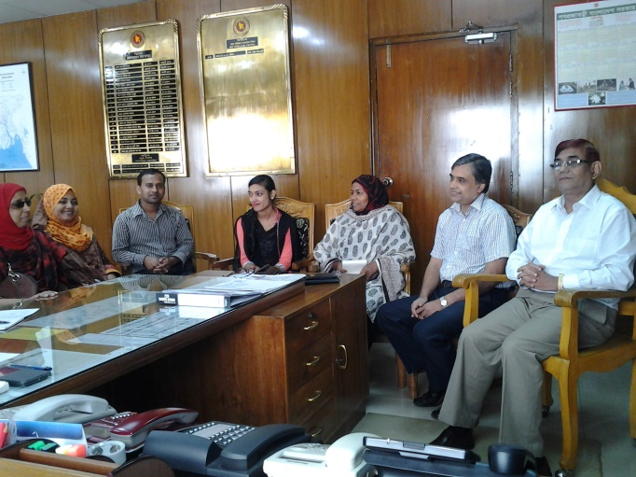Afterwards, Ashrafun Nahar, the Executive Director of WDDF, on behalf of the representatives of WDDF, submitted a paper including the accomplishment, objectives along with a few proposals and Shirin Akhter, Chairperson of WDDF, submitted a brief report on the activities for the promotion and protection of the rights along with dignity of Women with Disabilities to the Secretary and call upon to express the solidarity on behalf of Road, Transport and Bridge Ministry to these issues. Simultaneously, though the ‘Road and Transport Act 2016’ is already in the final stage for approval in the cabinet, but in accordance with the proposal of WDDF, He adopted decision to allocate maximum one week time for WDDF in order to include the issue of Persons with Disabilities specially, Women with Disabilities in this act and for taking necessary initiatives for ensuring the accessibility of Persons With Disabilities including Women with Disabilities in road, and transport, he invited Additional Secretary Mrs. Zahida Khanam and Mr. Abdul Malek in this discussion meeting and hand over the responsibility to communicate with us about this issue. He also said that, present Government is very compassionate to the Persons with disabilities and very much committed to fulfill their demands.

Above all, it is said that, in the present perspective, the adopted initiative by WDDF, of organizing this dialogue between the representatives of WDDF and the Secretary of Road, Transport and Bridge Ministry in order to include the Women with Disabilities in the mainstream of development by ensuring their equal rights along with dignity is really very time required and effective. At the end of the discussion meeting, the representatives after having been attended in the above mentioned meeting expressed their satisfactory feelings and positive remarks.

**W) The 23rd Discussion meeting with the State Minister of MOWCA:**

A discussion meeting was held between the representatives of WDDF and the State Minister of Ministry of Women and Children Affairs (MOWCA) on 19th October 2016, at 1 PM, in her office.

The representatives of WDDF attended in the above mentioned meeting. Meher Afroz Chumki State Minister of Ministry of Women and Children Affairs (MOWCA) expressed her heartiest thanks to the representatives of WDDF. Afterwards, Ashrafun Nahar, the Executive Director of WDDF, on behalf of the representatives of WDDF, submitted a report on including the issues of Women with Disabilities in CEDAW alternative report to the State Minister and call upon to express the solidarity on behalf of MOWCA to these issues.

**X) The 24th Discussion Meeting with the Chairman, Rajuk:**

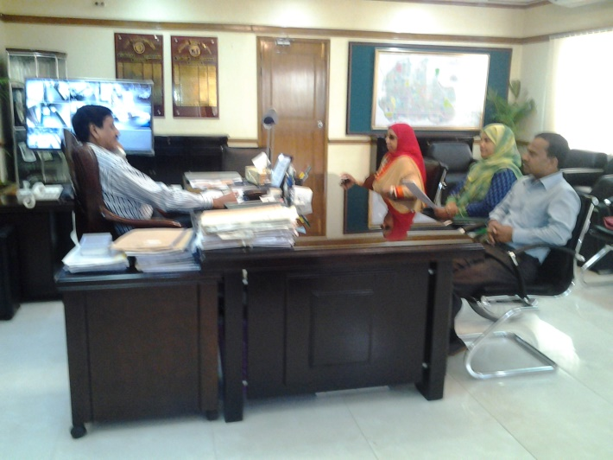A discussion meeting was held between the representatives of WDDF and the Chairman of Rajuk, on 24th October 2016, at 11.00 AM, in his office. The representatives of WDDF attended in the above mentioned meeting. M Bazlul Karim Chaudhury, Chairman of Rajuk expressed his heartiest thanks to the representatives of WDDF.

Afterwards, Ashrafun Nahar, the Executive Director of WDDF, on behalf of the representatives of WDDF, submitted a paper including the accomplishment, objectives along with a few proposals and Shirin Akhter, Chairperson of WDDF, submitted a brief report on the activities for the promotion and protection of the rights along with dignity of Women with Disabilities to the Chairman and call upon to express the solidarity on behalf of Rajuk to these issues. He also said that, present Government is very compassionate to the Persons with disabilities and very much committed to fulfill their demands. Above all, it is said that, in the present perspective, the adopted initiative by WDDF, of organizing this dialogue between the representatives of WDDF and the Chairman of Rajuk in order to include the Women with Disabilities in the mainstream of development by ensuring their equal rights along with dignity is really very time required and effective. At the end of the discussion meeting, the representatives after having been attended in the above mentioned meeting expressed their satisfactory feelings and positive remarks.

**Y) The 25th Discussion meeting with the Head of news of SA TV:**

A discussion meeting was held between the representatives of WDDF and the Head of News of SATV on 25th October 2016, at 11 AM, in SA TV office. the officials of WDDF attended in the above mentioned meeting. Mr. Mahmud Al Faisal, Head of News of SA TV, expressed his heartiest thanks to the representatives of WDDF. Afterwards, Ashrafun Nahar, the Executive Director of WDDF, on behalf of the representatives of WDDF, submitted a proposal for organizing a Talk show on ‘Accessibility of Persons with Disabilities including Women with Disabilities in Road, Footpath, Overbridge and Transport’, with the initiative of WDDF and call upon to express the solidarity on behalf of SA TV to this issue.

The Head of News was very cordial and cooperative to us. He expressed his interest to organize a talk Show regarding this issue as soon as possible and discussed about the detail budget and process to organize this type of Talk Show with WDDF. The representatives of WDDF were agreed to organize the Talk Show and on the basis of discussion it is decided that, this talk show is going to be organized on 26th October 2016.

Above all, it is said that, in the present perspective, the adopted initiative by WDDF, of organizing this discussion meeting between the representatives of WDDF and the Head of News of SA TV in order to include the Women with Disabilities in the mainstream of development by ensuring their accessibility rights through media campaign is really very time required and effective. At the end of the discussion meeting, the representatives after having been attended in the above mentioned meeting expressed their satisfactory feelings and positive remarks.

**Z) The 26th Discussion Meeting with the representatives of Christoffel-Blinden Mission (CBM):**

A discussion meeting was held between the representatives of WDDF and the representatives of Christoffel-Blinden Mission (CBM) on 1st November 2016, at 11 AM, in CBM office. Ashrafun Nahar, Executive Director and Reshma Akter, Project Officer of WDDF attended in the above mentioned meeting. Mr. Andrias,Coordinator, Disability Inclusive Development, Christoffel-Blinden Mission (CBM) has completed his working period in Bangladesh and on the occasion of his fare well the representatives of WDDF organized a sharing meeting about the present situation along with the future plan of WDDF in order to share about the prospective opportunities for the advancement of WDDF. He expressed his heartiest thanks to the representatives of WDDF.

Afterwards, CBM representative expressed the interest of CBM to develop a network but Ashrafun Nahar enlightened that, there are already Three/four networks are working on disability issue and at present we think that there is no requirement of developing any network rather a consortium might be developed. So, Andrias agreed with the representative of WDDF. Besides, she discussed about the consortium of women led organizations. Mr. Andrias welcomed this initiative and highly encouraged her to advance with this initiative.

**AA) The 27th Discussion meeting with the Director of Nilfamari DPOD:**

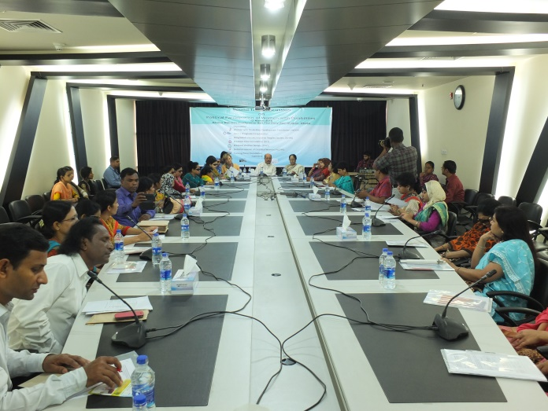We visited Nilfamari from 21st to 23rd November 2016 and organized A Discussion meeting with the Director of Nilfamari Disabled Peoples Organization to Development (DPOD) between the representatives of WDDF and the representatives of Nilfamari DPOD on 23rd November 2016, at 11 AM, in its office. This discussion meeting was being organized in order to collect and check the records of a plot of land of a very poor, orphan and victim Woman with Multiple Disability called Mohsina and how to rehabilitate her in this permanently. Shirin Akhter, Chairperson, Ashrafun Nahar, Executive Director, Md. Hasanuzzaman, Accounts Officer and Reshma Akter, Project Officer of WDDF attended in the above mentioned meeting. We’ve collected few papers of the land, checked in land office and came to know that, We’ve to collect more papers as well as mutation in her name is essential to establish her ownership in this land property which is very difficult in this short time plan. So, we decided that, we’ve to take long time program subsequently to complete the rest of tasks in this issue.

**5. Roundtable Discussion:**

A roundtable discussion on “Political Rights and Participation of Women With Disabilities” for the celebration of International Women Day is being organized with the initiative of seven organizations Women with Disabilities Development Foundation (WDDF), Access Bangladesh Foundation, Bangladesh Visually Impaired Peoples Society (BVIPS), Disabled Child Foundation (DCF), Disabled Welfare Society (DWS), National Council of Disabled Women (NCDW), Turning Point Foundation, from 10 AM to 1 PM, on Saturday 12th March 2016, at Azimur Rahman conference hall, the Daily Star Bhaban, on the issue of the Women With Disabilities are excluded from, their equal rights including political rights and participation” We Urge for an inclusive, antidiscriminatory and Women With Disabilities friendly society for all”. These Seven Organizations led by Women with Disabilities having united 1st time with the initiative of WDDF and working as collective force for their participation in mainstream of the society. The keynote paper was jointly being presented by Nazma Ara Begum Popy, General Secretary, Bangladesh Visually Impaired Peoples Society (BVIPS) and Nasima Akter, President, National Council of Disabled Women (NCDW). WWDs are deprived from practicing and enjoyment of political rights and participation though UNCRPD Article-29 ’Participation in political and public life’ noted that, states parties shal guarantee to PWDs political rights and the opportunity to enjoy them on an equal basis with others. In the consequence of our continuous advocacy and voice raising, ‘National Action Plan’ on ‘Women Advancement Policy2011’ has been mentioned Two reserve seats for WWDs in National Parliament but no initiative has been adopted to implement or actualize this decision.

In the light of realizing this situation, the Seven women led organizations have organized this roundtable discussion due to advancing forward with this issue. The participants of the open discussion have clearly been stated that, Without having been enjoyed political rights and participation, all types of Women With Disabilities haven’t been included in the mainstream of development and in this consequence, national development will extremely be interrupted. Advocate Abdul Matin Khasru, Member of Parliament, Convener Parliamentarian Caucus on Disability, was attended as Chief Guest in the program. Besides,Mr. Tariq Ul Islam, Secretary, Planning Ministry Bangladesh Secretariat,Kazi Reazul Hoque, Member, National Humanrights Commission (NHRC),Christine Hunter, Country Representative, UN Women and Ayesha Khanam, President, Bangladesh Mahila Parishad (BMP) were present in this roundtable discussion. This Roundtable Discussion is moderated by Ashrafun Nahar Misti, Executive Director, Women With Disabilities Development Foundation (WDDF). Welcome Speech is being delivered by Nasreen Jahan, Executive Director, Disabled Child Foundation (DCF). Closing speech and vote of thanks is delivered by Mohua Pal,Chairperson of Roundtable Discussion and Vice Chairperson Access Bangladesh Foundation.

**6.** **Grassroot Committee meeting of Women with Disabilities:**

WDDF organized Three Grassroot Committee meeting of Women with Disabilities in this reporting year.

**I) The 1st Grassroot Committee meeting of** **WWDs** of Doudkandi, Comilla as well as Upazila Women Officer was held on 21st March’2016, organized by WDDF, at Mukul Niketan in Kanora Union.

This meeting is presided over WDDF Chairperson Shirin Akhter, WDDF Vice Chairperson Masuma Akter and Project Officer Erona Khandakar were present in this discussion meeting.

Shamima Sultana, the Upazila Women Officer exchanged Greetings and shared her views about the activities of WDDF with the members of Grassroot Committee; she also discussed about the financial support along with assistive device provided by WDDF to the WWDs for starting IGA and continuing education as well as how to utilize this support properly. Furthermore, the women officer talked with the parents of WWds and suggested them not to be frustrated for their daughters with disabilities but to become more positive and cooperative to them for making them active along with contributive.

**II) The 2nd Grassroot Committee meeting of Women with Disabilities of Manikganj** was held on 22nd March’2016, organized by WDDF, at Manikganj Disable People’s Organization to Development (MDPOD) Rouhadaha,Manikgonj Sadar. The discussed issue of this meeting was celebration of International Women Day and its statement, WWDs rights on property and how to save the property from their neighbours as well as the initiatives of WWDs political participation. This meeting is led by Shirin Akhter, Chairperson, WDDF.

**III) The 3rd Grassroot committee meeting of Women with Disabilities:**

Monthly discussion meeting with the Grassroot WWDs Committee of Manikganj was organized by WDDF, on 4 May 2016, , at Manikganj Disable People’s Organization to Development (MDPOD) Rouhadaha,Manikgonj Sadar. The discussed issue of this meeting was Module-5, the rights of WWDs in accordance with the UNCRPD and how the state preserve the rights of WWDs through adopting different types of time required initiatives. Besides, an incident of family rights violation of women with severe (Both Knee and Wristless) physical disability of Manikganj by her husband, was being shocked all of us extremely and WDDF expressed it’s commitment to support this WWD (who has got marry and is going to be a mother), incollaboration with Manikganj. This meeting is led by Shirin Akhter, Chairperson, WDDF.

**7. One Stop Crisis Centre (OCC) of Khulna Medical College visit:**

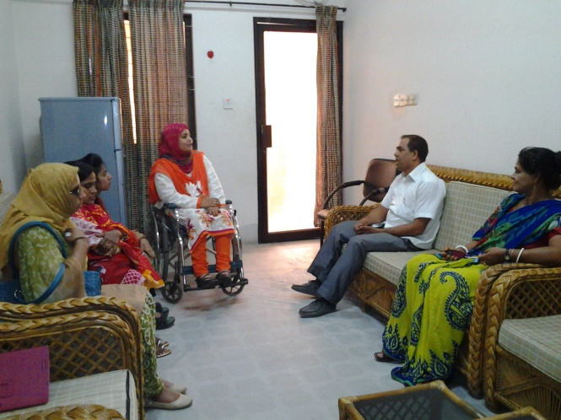WDDF representative team visited One Stop Crisis Centre (OCC) and organized a discussion meeting with the authorities of OCC, Khulna Medical College on 13th April2016. Chairmen Shirin Akhter, Executive Director Ashrafun Nahar Misti, Accounts Coordinator Md. Hasanuzzaman and Project Officer Erona khandakar were present in this meeting . They discussed about the services of OCC and also mentioned that if any WWDs has come here they should arrange special take care for their physical, mental and legal support along with cure. They have also suggested to maintain registration system and preserve the information in order to collect data of victim WWDs. The officers of OCC have agreed with WDDF about the special care for victim WWDs.

At the time of visiting, One incident surprised us; We noticed that, a 12 years girl with mild intellectual disability has come for support and through discussion with the incharge of OCC and the mother of the girl we came to know that, this girl was raped continuously by an influential village man and whenever she desired to express the issue of her continuous raping publicly, she faced threats of killing her by knife or different ways. While the incident was being brought to light, the female child has already pregnant for Five months but the village chairman hasn’t desired to bring the incident to light rather he pressured the victim family to mutual this terrific incident and heinous offence by money without considering the future of the female child.

On the other hand, the OCC officers are only responsible for counseling the victim along with her family as well as to file a case in local thana. WDDF representatives are counseling the female child along with her mother and encourage them for taking shelter of law with the cooperation of WDDF along with OCC authority through filing a case. Above all, this type of heinous offence of the influential persons called human monstrous shocked the representatives of WDDF extremely as well as we are reproaching this type of contemptible offence.

**8. Supporting program for a victim woman:** A discussion meeting for providing support to a victim woman was held with the Union Parishad Members and elid leaders in Tangail, on 9th April’16. Majeda Akter, a victim woman with her two children was continuously tortured by her husband and his family members as well as at the period of continuous torture, she became frustrated and compelled to come back to her parents house. Majeda with her children started to live with her mother for three years, who is a domestic worker. Majeda’s mother informed this issue to the Executive Director of WDDF and asked her cooperation. With the cooperation of WDDF, Majeda filed a case against her husband. Simultaneously, on behalf of WDDF, this issue is being discussed with lawyer and local thana officers and warrant has been issued to arrest him. After that, Majeda’s husband and his family started to communicate with Majeda and her family for taking back her in her family but Majeda has to withdraw the case. In this situation, Majeda’s parents couldn’t understand what should to do but with the suggestion of WDDF, Majeda’s parents has arranged a village salish with the elid leaders and the union parishad members of both unions, in the presence of WDDF representatives as well as Majeda’s husband and his family members. The elid leaders and Union Parishad members 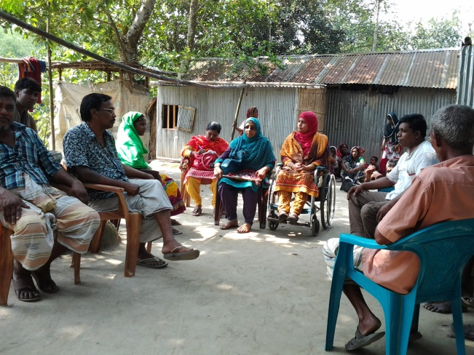handed over the responsibility of this salish to WDDF and the representatives of WDDF has led the discussion as well as on the basis of discussion of all the members, it is decided that an agreement has been signed between the parents of both Majeda and her husband mentioning that, Majeda will go back to her father in-law’s house but Majeda’s husband and his family members have to stop all types of torture to her and in that condition case will be withdrawn otherwise, if Majeda will become victim of torture, case will be executed again. Hence, according to the dicision of all the members the agreement has been signed, two family are being united again and Majeda went back with her husband in her father in law’s family.

8.  **Press Conference:**

A press Conference for getting justice of violation of women, human rights along with family rights of a WWD, with the initiative of WDDF was being organized a **Press Conference** held on 28th October, 2015 at Narail Pressclub. WDDF Chairman Shirin Akhter delivered the welcome speech; Executive Director Ashrafun Nahar Misti present the keynote paper. Both Chairmen and Executive Director of WDDF answer the queries of journalists. Rabeya Yusuf, Secretary General,Zila Mohila krira Sangstha, Advocate . Rowshan Ara kabir Lili, Afroza Khatun, Executive Director, Narail Asher Alo Foundation, besides, representatives of NGOs and CSOs were also present in that press conference.

**9. Training** **of Women with Disabilities on different Legislations:**

WDDF organized Four Trainings of Women with Disabilities on different Legislations in this reporting year.

1. Training on ‘Right To Information Act (RTI)’:

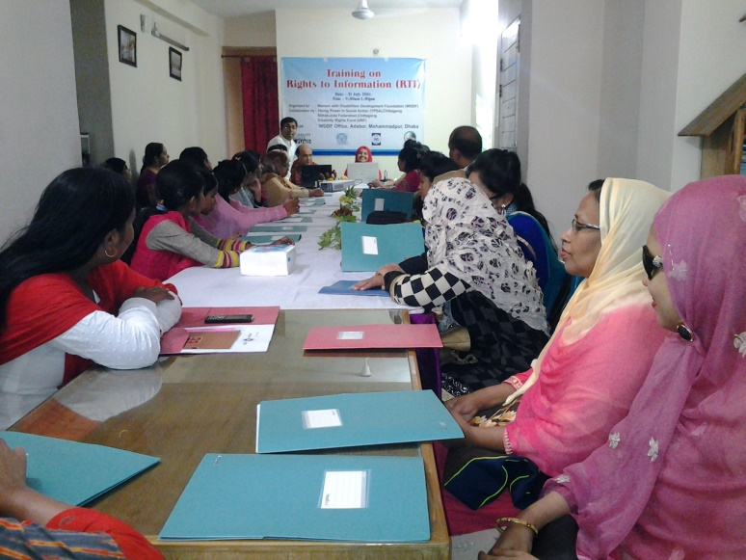A Training on ‘Right To Information Act (RTI)’ was being held on 31st July 2016, at the auditorium of Women with Disabilities Development Foundation (WDDF). This training with the participation of 31 different types of Women with disabilities, is being organized by Women with Disabilities Development Foundation (WDDF) in collaboration with Sitakund Federation of DPO. A constructive and illustrative presentation is being delivered by the resource person of this training, Mr. Rejaul Karim Siddiquee,Advocate Supreme Court and Senior Researcher Bangladesh Legal Services and Trust (BLAST). Mr. Vaskar Vatta Chariya, National Consultant, Web Accessibility A To I, Prime Minister’s Office and President of Sitakund Federation of DPO was present in the abovementioned training.

This training is being started at 10.00 AM, 31st July 2016, with the welcome remarks of Shirin Akhter, Chairperson and Ashrafun Nahar, Executive Director of WDDF including the required information and expected learnings/aims of this training. After that, an introductory session of all the participants and representatives is being conducted by Ashrafun Nahar and all the participants and representatives are introduced with each other in this session

After having introductory session been finished, Mr. Vaskar Vatta Chariya, National Consultant, Web Accessibility A To I, Prime Minister’s Office and President of Sitakund Federation of DPO is being requested to deliver his speech. In his speech he noted that, now it is immensely important for all types of Women with Disabilities to gain knowledge and experience about different legislations, policy and technology concurrently the utilizing methods of these legislations, policy along with technology; otherwise it will be very difficult for them to enjoy their rights properly. Besides, he delivered a brief and valuable presentation on accessible technology for Persons with Disabilities.

Followed by the introductory session, the resource person started his key presentation on ‘Right To Information Act (RTI) and this presentation includes:

1. What is RTI?

II) How are the people benefited through utilizing this legislation?

III) What type of information can we get through utilizing this legislation?

IV) How can we apply for getting information?

V) How can we fill the form up?

VI) What type of sources are accountable to provide information?

VII) What is Information Commission? And What its responsibility?

Many questions come from participants in the question-answer session, the resource person responded all the questions and he clearly clarified how to apply for getting information from different sources. He also assured that, in collaboration with WDDF, he will always be ready to cooperate Persons specially Women with Disabilities to apply and to obtain information through utilizing this legislation.

From the responses of all the participants, it would be noted that, this is an effective and time required training for them. Most of the participants have no idea about this legislation and easy along with preferable method of getting accurate and required information. The participants are also pointed out that, Persons specially Women with Disabilities of remote areas are deprived from Government services and facilities and due to lack of accurate information they are always left behind. So, considering the susceptibility of Persons specially Women with Disabilities, this type of training should be organized in divisional and district level

**B) Training on ‘Persons with Disabilities Rights and Protection Act 2013’:**

A Training with the participation of 30 different types of Women with disabilities, on ‘Persons with Disabilities Rights and Protection Act 2013’was being organized by Women with Disabilities Development Foundation (WDDF) in its own auditorium, on 31st July 2016. A constructive and illustrative presentation is being delivered by the resource person of this training, Ms. Ashrafun Nahar,Executive Director of WDDF. Mr. Jibon William Gomej, Facilitator, Abilis Foundation and Executive Director of Turningpoint Foundation was present in the abovementioned training.

This training is being started at 2.00 PM, 31st July 2016, with the welcome remarks of Shirin Akhter, Chairperson and Ashrafun Nahar, Executive Director of WDDF including the required information and expected learnings/aims of this training. After that, an introductory session of all the participants is being conducted by Ashrafun Nahar and all the participants are introduced with each other in this session. After having introductory session been finished, Mr. Jibon William Gomej Facilitator, Abilis Foundation and Executive Director of Turningpoint Foundation is being requested to deliver his speech. In his speech he noted that, now it is immensely important for all types of Women with Disabilities to gain knowledge and experience about different legislations and policy specially this legislation entitled ‘Persons with Disabilities Rights and Protection Act 2013’, though this act hasn’t been addressed the issue of Women with Disabilities separately. Concurrently the utilizing methods of these legislations and policy; otherwise it will be very difficult for them to enjoy their rights properly. 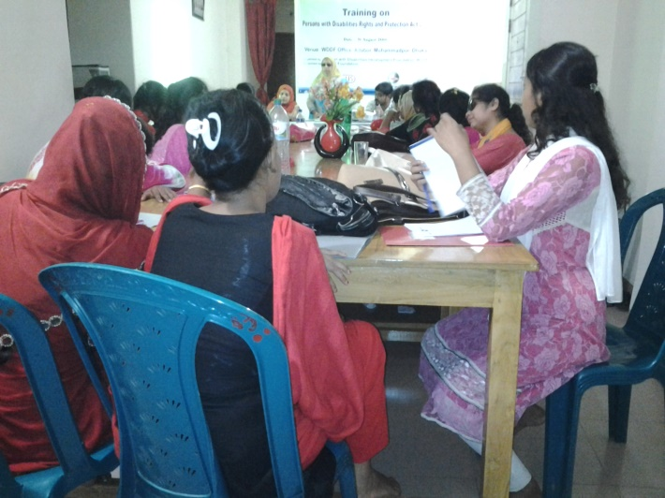

Followed by the introductory session, the resource person started her key presentation on ‘Persons with Disabilities Rights and Protection Act 2013’ and this presentation includes:

1. Logicality of Persons with Disabilities Rights and Protection Act 2013,

II) Types of disability,

III) Vitality and utilization of this legislation for Persons with Disabilities,

IV) Fundamental rights of Persons with Disabilities in accordance with this legislation,

V) Different committees mentioned in the legislation and their responsibilities,

VI) Justice, free from torture and legal support of this legislation,

VII) No separation and Social inclusion.

The resource person suggested to the participants that, everybody should have proper conception and knowledge about this legislation concurrently they should have try to use the specific reference of this legislation for utilizing in required area. In case of any requirement, WDDF will always take proper initiative to cooperate to the Women with Disabilities through legal aid service providing organizations. Otherwise, it will be very difficult for them to enjoy their rights through the implementation of this legislation properly.

From the responses of all the participants, it would be noted that, this is an effective and time required training for them. Most of the participants have come to know the name of this legislation but they aren’t aware about the basic rights for Persons with Disabilities are mentioned in this legislation. The participants are also pointed out that, Persons specially Women with Disabilities of remote areas are deprived from Government services and facilities and due to lack of accurate information they are always left behind. So, considering the susceptibility of Persons specially Women with Disabilities, this type of training should be organized in divisional and district level

**C) Training on ‘Persons with Disabilities Rights and Protection Act 2013’:** A Training with the participation of 30 different types of Women with disabilities, on ‘Persons with Disabilities Rights and Protection Act 2013’was being organized by Women with Disabilities Development Foundation (WDDF) in its own auditorium, on 31st August 2016. A constructive and illustrative presentation is being delivered by the resource person of this training, Ms. Shirin Akhter, Chairperson of WDDF and facilitated by Mr. Protik John Rojario, Capacity building Officer of Turningpoint Foundation.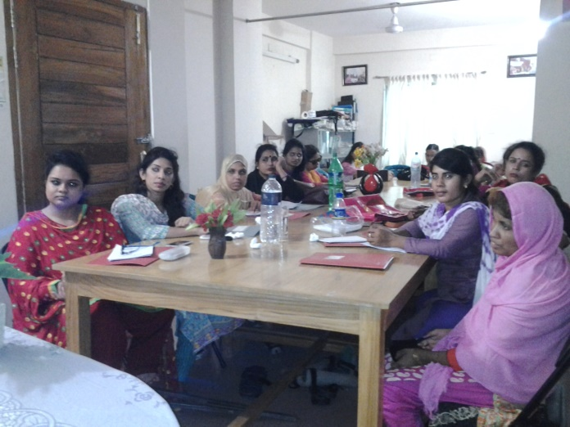This training is being started at 10 AM, 31st August 2016, with the welcome remarks of Shirin Akhter, Chairperson of WDDF including the required information and expected learnings/aims of this training. After that, an introductory session of all the participants is being conducted by Shirin Akhter and all the participants are introduced with each other in this session

After having introductory session been finished, the resource person started her key presentation on ‘Persons with Disabilities Rights and Protection Act 2013’ and this presentation includes:

1. Logicality of Persons with Disabilities Rights and Protection Act 2013,

II) Types of disability,

III) Vitality and utilization of this legislation for Persons with Disabilities,

IV) Fundamental rights of Persons with Disabilities in accordance with this legislation,

V) Different committees mentioned in the legislation and their responsibilities,

VI) Justice, free from torture and legal support of this legislation,

VII) No separation and Social inclusion.

The resource person suggested to the participants that, everybody should have proper conception and knowledge about this legislation concurrently they should have try to use the specific reference of this legislation for utilizing in required area. In case of any requirement, WDDF will always take proper initiative to cooperate to the Women with Disabilities through legal aid service providing organizations. Otherwise, it will be very difficult for them to enjoy their rights through the implementation of this legislation properly.

From the responses of all the participants, it would be noted that, this is an effective and time required training for them. Most of the participants have come to know the name of this legislation but they aren’t aware about the basic rights for Persons with Disabilities are mentioned in this legislation. The participants are also pointed out that, Persons specially Women with Disabilities of remote areas are deprived from Government services and facilities and due to lack of accurate information they are always left behind. So, considering the susceptibility of Persons specially Women with Disabilities, this type of training should be organized in divisional and district level

**D) Training on** **‘****Women and Children Repression Prevention Act 2000’:** 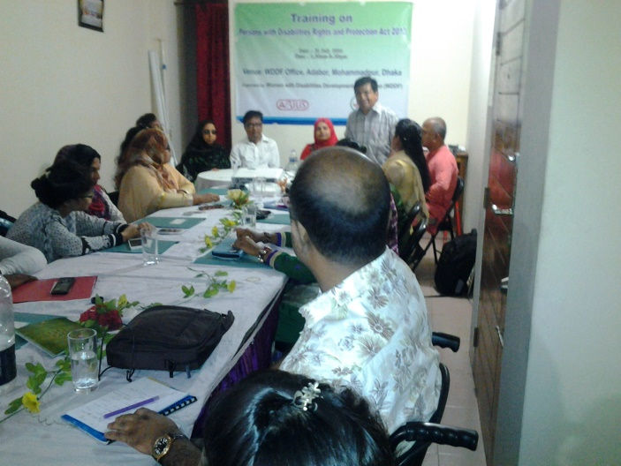A Training on ‘Women and Children Repression Prevention Act 2000’ was being held on 29th September 2016, at the auditorium of Women with Disabilities Development Foundation (WDDF). This training with the participation of 31 different types of Women with disabilities, is being organized by Women with Disabilities Development Foundation (WDDF). A constructive and illustrative presentation is being delivered by the resource person of this training, Mr. Rejaul Karim Siddiquee,Advocate Supreme Court and Senior Researcher Bangladesh Legal Services and Trust (BLAST). This training is being started at 10.00 AM, 31st July 2016, with the welcome remarks of Shirin Akhter, Chairperson and Ashrafun Nahar, Executive Director of WDDF including the required information and expected learnings/aims of this training. After that, an introductory session of all the participants is being conducted by Ashrafun Nahar and all the participants are introduced with each other in this session

After having introductory session been finished, the resource person started his key presentation on ‘Women and Children Repression Prevention Act 2000’ and this presentation includes:

1. What is Women and Children Repression Prevention Act?

II) How are the women and children benefited through utilizing this legislation?

III) What type of procedures and which articles we’ve to follow carefully for utilizing this legislation?

IV) How can we apply for getting justice through utilizing this legislation?

V) which articles are excluded from this legislation?

VI) What type of complexity Women along with the Children with Disabilities have to face due to having not addressed their issue totally as well as their special needs according to the types of disabilities?

VII) How to handle rape case? And What is the punishment along with the compensation process of the offender?

Many questions come from participants in the question-answer session, the resource person responded all the questions and he clearly clarified how to utilize this legislation. He also assured that, in collaboration with WDDF, he will always be ready to cooperate Persons specially Women with Disabilities to apply and to obtain information through utilizing this legislation.

From the responses of all the participants, it would be noted that, this is an effective and time required training for them. Most of the participants have no idea about this legislation and easy along with preferable method of getting accurate and required information. The participants are also pointed out that, Persons specially Women with Disabilities of remote areas are deprived from Government services and facilities and due to lack of accurate information they are always left behind. So, considering the susceptibility of Persons specially Women with Disabilities, this type of training should be organized in divisional and district level

**10. Training on ‘Reproductive health Rights of Women With Disabilities’:**Two Trainings on ‘Reproductive Health Rights of Women with Disabilities’ were being organized in this reporting period:

A) The 1st training on ‘Reproductive Health Rights of Women with Disabilities’ was being held on 1st August 2016 and

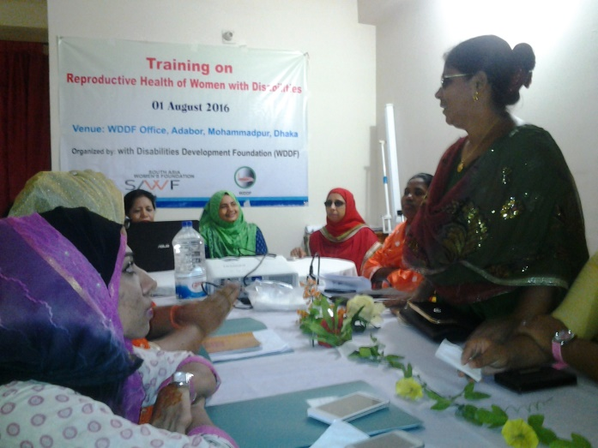B) The 2nd training on ‘Reproductive Health Rights of Women with Disabilities’ was being held on 30th August 2016. These Two trainings with the participation of 50 different types of Women with disabilities, are being organized by Women with Disabilities Development Foundation (WDDF) in its own auditorium. There were Three resource persons to conduct the training theoretically and practically for the Women with Disabilities properly. A constructive and illustrative presentation on different parts of human body regarding reproductive health is being delivered by the resource persons of these trainings, Mrs. Khaleda Begum, Chief trainer, and Nargis Akter Lipy, Centre Manager (Expert on Reproductive Health Rights) Young Power in Social Action (YPSA) were present in the abovementioned training.

These trainings are being started at 10.00 AM, both 1st and 2nd August 2016, with the welcome remarks of Shirin Akhter, Chairperson and Ashrafun Nahar, Executive Director of WDDF including the required information and expected learnings/aims of these trainings. After that, an introductory session of all the participants is being conducted by

Ashrafun Nahar and all the participants are introduced with each other in this session After having introductory session been finished, the resource personss started their presentation on ‘Reproductive Health Rights of Women with Disabilities’ and this presentation includes:

1. What is reproductive health?

II) importance of reproductive health for Women with Disabilities.

III) What is periodic cycle?

IV) What type of physical and mental changes are being felt and visible in the body of both female and male in their adolescence period?

V) Which parts of female and male body are specially considered under reproductive health? What are these parts?

VI) What type of initiatives for caring and consciousness we should follow at the time of ministration?

VII) What is sexual relation? How does a woman become pregnant through sexual relation of Two persons?

VIII) What types of complexity women have to face through the interruption of prevention of women disease and protection of reproductive health?

Besides, many important issues about reproductive health are discussed elaborately in the question answer session.

Learnings of these trainings: in the closing speech the participants pointed out that, their learnings from these trainings are as follows:

1. As Women with Disabilities, they obtained opportunity for the first time to discuss about reproductive health openly as well as to be acquainted with the secret and hidden parts/issues of human body.
2. II) As most of the women are unmarried, they’ve no idea about sex along with sexual relation. So, they got opportunity to gain knowledge about the internal parts and to identify the external parts of (Men and Women) humanbody practically. Hence, this training is immensely important for them.

III) Hygienic practise at the periodic time.

IV) How to maintain periodic cycle and how to save them selves from unexpected pregnancy.

V) Required information about taking care and safety of reproductive health.

VI) Reproductive health is as equally important for Women with Disabilities and they should have consciousness regarding this issue like non disabled women.

Finally, it is mentioned that, All The participants recommended that this training environment is very friendly for them where they’ve got opportunity to discuss every issue openly and elaborately. Simultaneously, they’ve learned many important issues about reproductive health. So, they’ve agreed that it is an effective training for them & they are interested to continue this training subssequently and for long time in district along with divisional level.

**11. Talk Show:** WDDF organized Three Talk show about “Universal Accessibility of Persons With Disabilities” in this reporting year.

1. Radio Talkshow:

On the occasion of 48th White Cane Safety Day WDDF organized Two Radio Talkshows:

1. The 1st Radio Talkshow was being organized at 11 AM, on 15th October 2016, in ‘Radio Amar’, and

II) The 2nd Radio Talkshow was being organized at 1.00 PM, on 15th October 2016, in ‘Radio ABC’. The discussing issue of these Two Talk shows is Universal Accessibility for Persons with Disabilities.

Shirin Akhter, Chairperson, Ashrafun Nahar, Executive Director, M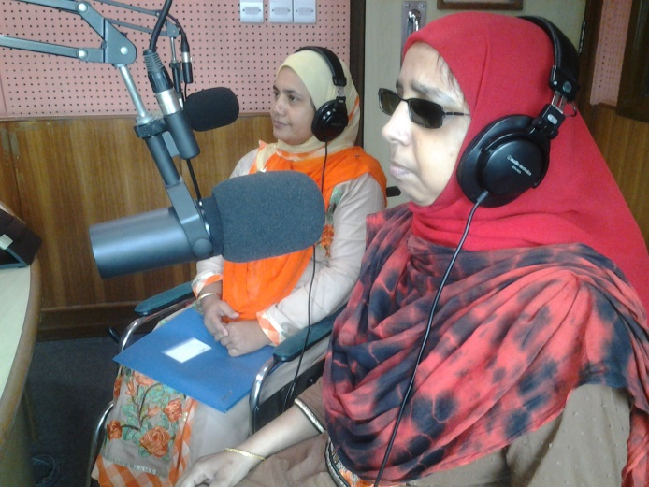d. Hasanuzzaman, Accounts Officer and Reshma Akter, Project Officer were participated in these Talkshows. The existing barriers and challenges in accessibility of Persons with Disabilities specially, Women with Disabilities in Road, footpath, overbridge, public transport and public buildings are enlightened to the audience. Simultaneously, it has also been clearly pointed out through the discussion of the representatives of WDDF that, how the national development has been interrupted due to the inaccessibility of Persons with Disabilities in all aspects of the society. Shirin Akhter, Chairperson, WDDF discussed about the complexity Women with Disabilities always have to face, the cause and their uninterrupted sufferings due to such existing inaccessible environment for them. Simultaneously, she pointed out the initiatives have been adopted by WDDF in order to include Women with Disabilities in mainstream development through reducing this complexity of inaccessibility as well as she also has mentioned about the importance of allocation and proper utilization of national budget on behalf of Government for reducing the barriers in the areas of accessibility.

Md. Hasanuzzaman, Accounts Officer, WDDF stated that, Sustainable Development Goals (SDGs) include the issue of inclusive and sustainable city along with human settlements in its Goal-11. So, without considering the issue of Universal Accessibility for Persons with Disabilities, Bangladesh won’t be able to actualize the targets of SDGs.

Ashrafun Nahar, Executive Director, WDDF discussed about the national and international legislations, documents and declarations in order to ensure the Universal Accessibility for Persons with Disabilities and how the Women with severe Disabilities have been deprived from national development process due to existing inaccessible environment. Mentioning about the Government initiatives she said that, despite of having number of Government declarations and orders for creating Universal Accessibility but no one of those has been implemented properly. Most of the public buildings, roads, footpaths overbridges are being designed and constructed as well as all types of transports are being exported without considering the needs and demands of Persons with Disabilities. Specially Women with Disabilities. Simultaneously, mentioning that, WDDF is enthusiastic to provide technical suggestion and cooperation in this ground, she urged to all the audience, representatives of civil society and media to raise their voice and come forward to solve this crisis through discussion. She also urged to the policy makers, Government along with the related and responsible authorities of creating Universal Accessibilities to adopt time required and proper initiatives to reduce this dilemma considering the types along with the requirements of Persons with Disabilities. Otherwise, the dream of poverty free Bangladesh will ultimately be interrupted due to unproductivity, ineffectiveness, backwardness and social exclusion of almost 24 million Persons with Disabilities.

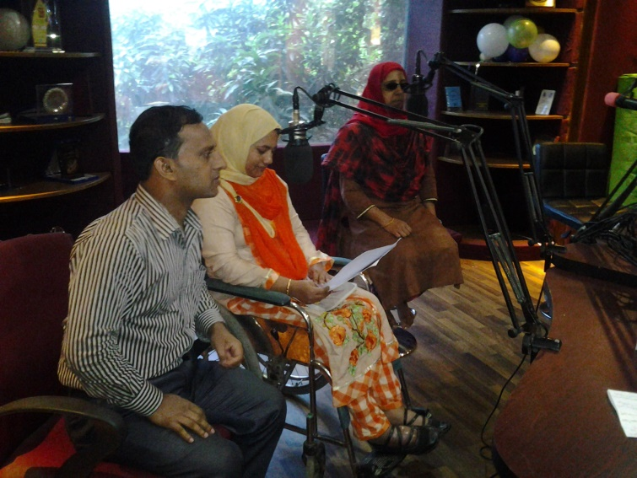**B) TV Talkshow:**

The 3rd Talkshow with the initiative of WDDF was being organized in collaboration with SA TV with the participation of the representatives of WDDF, DPOs, different types of institutions, Architects and civil society. This talk show entitled “Universal Accessibility of Persons with Disabilities” is being recorded at 7 PM, on 26th October 2016, and broadcasted on 27th October 2016. The allocated time for the program is One and half hour and this program is being divided in to Two parts: The rackonteurs of the 1st part were Mr. Mobasser Ali, former Chief Architect, Architecture Department.

The rackonteurs of the 2nd part were Ashrafun Nahar, Executive Director, Women with Disabilities Development Foundation (WDDF) and Mr. Iqbal Habib, Architect and City specialist.

In the speech of the conversessionalists, the existing barriers and challenges in accessibility of Persons with Disabilities specially, Women with Disabilities in Road, footpath, overbridge, public transport and public buildings are enlightened to the audience. Simultaneously, it has also been clearly pointed out through the discussion of the conversessionalists that, how the national development has been interrupted due to the inaccessibility of Persons with Disabilities in all aspects of the society.

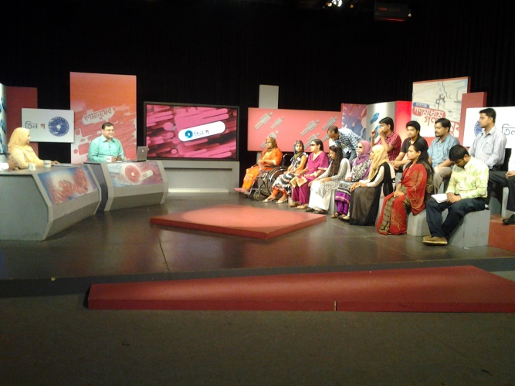

The speakers are also discussed the complexity Women with Disabilities always have to face, the cause and their uninterrupted sufferings due to such existing inaccessible environment for them. Simultaneously, it is demonstrated that, the initiatives have been adopted by WDDF in order to include Women with Disabilities in mainstream development through reducing this complexity of inaccessibility as well as it also has mentioned about the importance of allocation and proper utilization of national budget on behalf of Government for reducing the barriers in the areas of accessibility. Besides, Speakers are also discussed about national and international legislations, documents and declarations in order to ensure the Universal Accessibility for Persons with Disabilities and how the Women with severe Disabilities have been deprived from national development process due to existing inaccessible environment. Mentioning about the Government initiatives speakers said that, despite of having number of Government declarations and orders for creating Universal Accessibility but no one of those has been implemented properly. Most of the public buildings, roads, footpaths overbridges are being designed and constructed as well as all types of transports are being exported without considering the needs and demands of Persons with Disabilities.

Simultaneously, mentioning that, WDDF is enthusiastic to provide technical suggestion and cooperation in this ground, the Executive Director of WDDF urged to all the audience, representatives of civil society and media to raise their voice and come forward to solve this crisis. It is also urged in this talk show to the policy makers, Government along with the related and responsible authorities of creating Universal Accessibilities to adopt time required and proper initiatives to reduce this dilemma considering the types along with the requirements of Persons with Disabilities. Otherwise, due to unproductivity, ineffectiveness, backwardness and social exclusion of almost 24 million Persons with Disabilities, the dream of poverty free Bangladesh will ultimately be interrupted.

**12. Dialogue:**

A dialogue entitled “**Accessibility Rights of women with disabilities in Road, Public Transport and Public Buildings**” is being organized with the initiative of Women with Disabilities Development Foundation (WDDF), from 10 AM to 1 PM, on Sunday 16th October 2016, at VIP Lounge, National Presclub, in order to discuss the scenario of the accessibility right of Women With Disabilities in **Road, Public transport & Public buildings** and how their advancement is being interrupted due to depriving them from this momentous right. We urge for an inclusive, anti discriminatory and Women with Disabilities friendly society for all. WDDF run and led by Women with Disabilities has been working as collective force with the Government, policy makers, representatives of civil society and media for the inclusion of Women with Disabilities in mainstream development process through reducing their challenges and discrimination in the issue of accessibility. The dialogue was being moderated and keynote paper was being presented by Ashrafun Nahar, Executive Director, Women with Disabilities Development Foundation (WDDF). In this paper she mentioned that the number of Women with Disabilities (WWDs) is half of the total population with disabilities of Bangladesh. This large number of girls and Women with Disabilities in Bangladesh are one of the most vulnerable and disadvantaged segment of the society. They are always discriminated based on gender, disabled and all too often, poorest of the poor. They are frequently subjected to discrimination both directly and indirectly and also negative attitudes. In spite of having arrived in the 21st Century, there is no accessible road and public transport for Persons with Disabilities. So, the scenario of the movement of Women with disabilities is extremely vulnerable in the existing situation. Though UNCRPD Article-9 ’Accessibility noted that, enable persons with disabilities to live independently and participate fully in all aspects of life, States Parties shall take appropriate measures to ensure to persons with disabilities access, on an equal basis with others, to the physical environment, to transportation, to information and communications, including information and 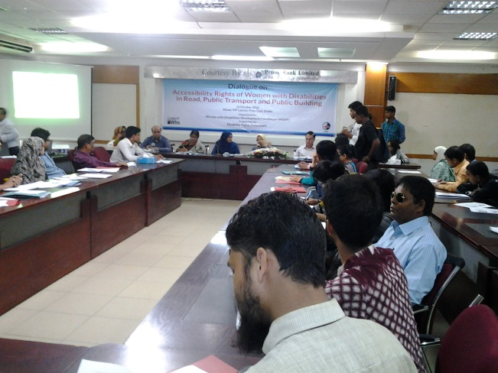communications technologies and systems, and to other facilities and services open or provided to the public, both in urban and in rural areas.

In the consequence of our continuous advocacy and voice raising, ‘National Action Plan’ on ‘Women Advancement Policy2011’ has been mentioned Two reserve seats for WWDs in National Parliament but no initiative has been adopted to implement or actualize this decision.

In the light of realizing this situation, WDDF has organized this dialogue due to advancing forward with this issue.

The participants of the open discussion have clearly been stated that, Without having been enjoyed political rights and participation, all types of Women With Disabilities haven’t been included in the mainstream of development and in this consequence, national development will extremely be interrupted. Nasima Begum (NDC), Secretary, Ministry of Women and Children Affairs (MOWCA) Bangladesh Secretariat was attended as Chief Guest in the program. Besides, Professor Dr. Shafique Siddique, Department of Accounting and Information Science, University of Dhaka,

Mr. Vaskar Vattacharya, National Consultant Web Accessibility A to I Prime Minister Office and Advocate Tahmina Begum, Assistant Director, Bangladesh National Women Lawyers Association (BNWLA) were present in this dialogue.

Welcome Speech is being delivered by Shirin Akhter, Chairperson, Women with Disabilities Development Foundation (WDDF) and vote of thanks is being delivered by Sanjida Akter, Executive Member, WDDF.